BOOT PROCESS

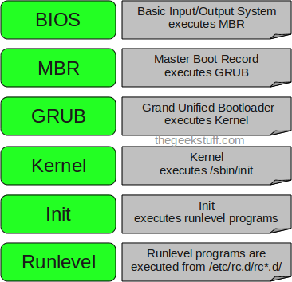

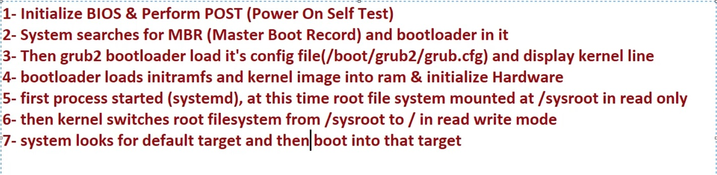

1. BIOS
- BIOS stands for Basic Input/Output System
- Performs some system integrity checks
- Searches, loads, and executes the boot loader program.
- It looks for boot loader in floppy, cd-rom, or hard drive. You can press a key (typically F12 of F2, but it depends on your system) during the BIOS startup to change the boot sequence.
- Once the boot loader program is detected and loaded into the memory, BIOS gives the control to it.
- So, in simple terms BIOS loads and executes the MBR boot loader.

2. MBR
- MBR stands for Master Boot Record.
- It is located in the 1st sector of the bootable disk. Typically /dev/hda, or /dev/sda
- MBR is less than 512 bytes in size. This has three components
1) primary boot loader info in 1st 446 bytes
2) partition table info in next 64 bytes
3) mbr validation check in last 2 bytes.
- It contains information about GRUB (or LILO in old systems).
- So, in simple terms MBR loads and executes the GRUB boot loader.

3. GRUB
- GRUB stands for Grand Unified Bootloader.
- If you have multiple kernel images installed on your system, you can choose which one to be executed.
- GRUB displays a splash screen, waits for few seconds, if you don’t enter anything, it loads the default kernel image as specified in the grub configuration file.
- GRUB has the knowledge of the filesystem (the older Linux loader LILO didn’t understand filesystem).
- Grub configuration file is /boot/grub/grub.conf (/etc/grub.conf is a link to this). The following is sample grub.conf of CentOS.
#boot=/dev/sda
default=0
timeout=5
splashimage=(hd0,0)/boot/grub/splash.xpm.gz
hiddenmenu
title CentOS (2.6.18-194.el5PAE)
root (hd0,0)
kernel /boot/vmlinuz-2.6.18-194.el5PAE ro root=LABEL=/
initrd /boot/initrd-2.6.18-194.el5PAE.img
- As you notice from the above info, it contains kernel and initrd image.
- So, in simple terms GRUB just loads and executes Kernel and initrd images.

4. Kernel
- Mounts the root file system as specified in the “root=” in grub.conf
- Kernel executes the /sbin/init program
- Since init was the 1st program to be executed by Linux Kernel, it has the process id (PID) of 1. Do a ‘ps -ef | grep init’ and check the pid.
- initrd stands for Initial RAM Disk.
- initrd is used by kernel as temporary root file system until kernel is booted and the real root file system is mounted. It also contains necessary drivers compiled inside, which helps it to access the hard drive partitions, and other hardware.

5. Init
- Looks at the /etc/inittab file to decide the Linux run level.
- Following are the available run levels
  - 0 – halt
  - 1 – Single user mode
  - 2 – Multiuser, without NFS
  - 3 – Full multiuser mode
  - 4 – unused
  - 5 – X11
  - 6 – reboot
- Init identifies the default initlevel from /etc/inittab and uses that to load all appropriate program.
- Execute ‘grep initdefault /etc/inittab’ on your system to identify the default run level
- If you want to get into trouble, you can set the default run level to 0 or 6. Since you know what 0 and 6 means, probably you might not do that.
- Typically you would set the default run level to either 3 or 5.

6. Runlevel programs
- When the Linux system is booting up, you might see various services getting started. For example, it might say “starting sendmail …. OK”. Those are the runlevel programs, executed from the run level directory as defined by your run level.
- Depending on your default init level setting, the system will execute the programs from one of the following directories.
  - Run level 0 – /etc/rc.d/rc0.d/
  - Run level 1 – /etc/rc.d/rc1.d/
  - Run level 2 – /etc/rc.d/rc2.d/
  - Run level 3 – /etc/rc.d/rc3.d/
  - Run level 4 – /etc/rc.d/rc4.d/
  - Run level 5 – /etc/rc.d/rc5.d/
  - Run level 6 – /etc/rc.d/rc6.d/
- Please note that there are also symbolic links available for these directory under /etc directly. So, /etc/rc0.d is linked to /etc/rc.d/rc0.d.
- Under the /etc/rc.d/rc*.d/ directories, you would see programs that start with S and K.
- Programs starts with S are used during startup. S for startup.
- Programs starts with K are used during shutdown. K for kill.
- There are numbers right next to S and K in the program names. Those are the sequence number in which the programs should be started or killed.
- For example, S12syslog is to start the syslog deamon, which has the sequence number of 12. S80sendmail is to start the sendmail daemon, which has the sequence number of 80. So, syslog program will be started before sendmail.
There you have it. That is what happens during the Linux boot process.

- systemctl get-default
OUTPUT – graphical.target

- systemctl list-units (will show all services)

- systemctl set-default graphical.target (will boot in graphical mode)

- systemctl set-default multi-user.target (will boot in CLI mode)
- systemctl set-default emergency.target (for troubleshooting purpose)
- systemctl set-default rescue.target (for troubleshooting purpose)

TWO WAYS TO COME OUT FROM CLI MODE
- RUN THIS COMMAND
- Startx

- RUN THIS COMMAND
- Systemctl isolate graphical.target

IQ - If you forgot your passwerd when you are logged on a running surver then?
ANS - You can change your password by passwd command. System will not ask you old password.

IQ - If you forgot your passwerd and you are not logged on your surver then?(HOW TO BREAK/RESET ROOT PASSWORD)
ANS
- Restart your machine.
- When you see kernel images press up-down arrow keys.
- 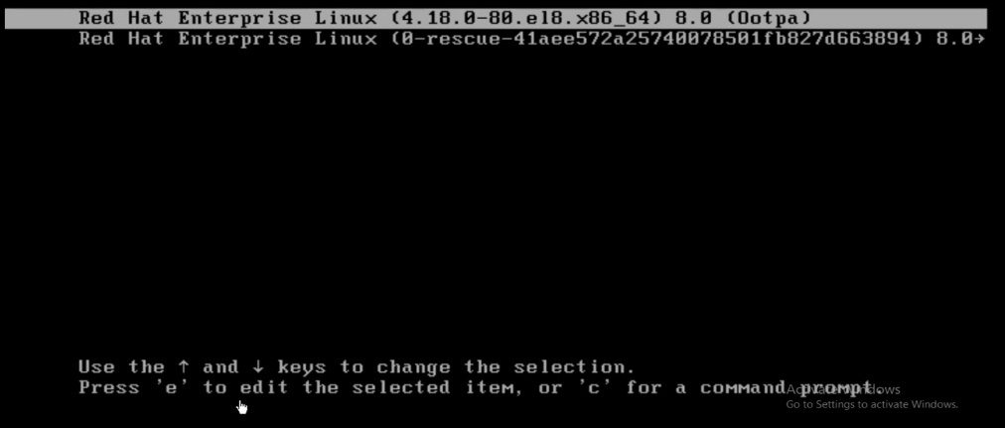
- Select upper image and press e button.
- Then you will see kernel CLI like this.
- 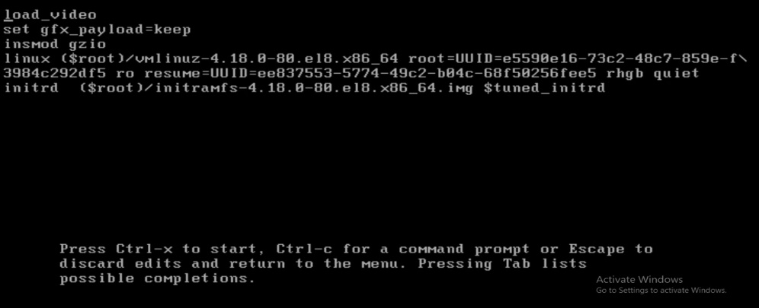
- Then edit in linux line at the end “rd.break”(means we are breaking Ram Disk in the mid. And we will get early shell. Take help from down image)

- 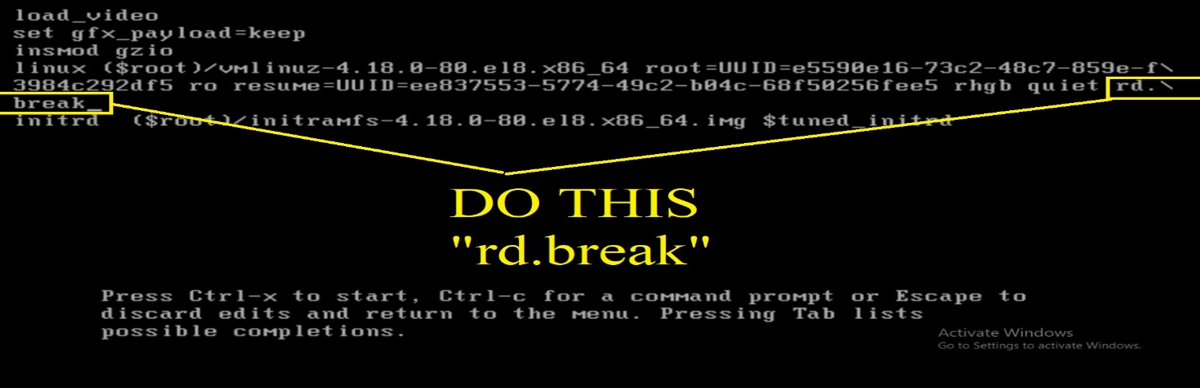
- Then press Ctrl+x to start.
- Then you will get emergency mode.
- Then run this command.
  - mount -o remount,rw /sysroot
  - chroot /sysroot
  - passwd
- Then Enter your new password.
- Then run this command.
  - touch /.autorelabel (It will relabel your whole filesystem)
  - exit
  - exit

HOW TO BREAK/RESET ROOT PASSWORD BY RUPESH SIR
